
Sunset Hike
to Boucher Point
July 3rd
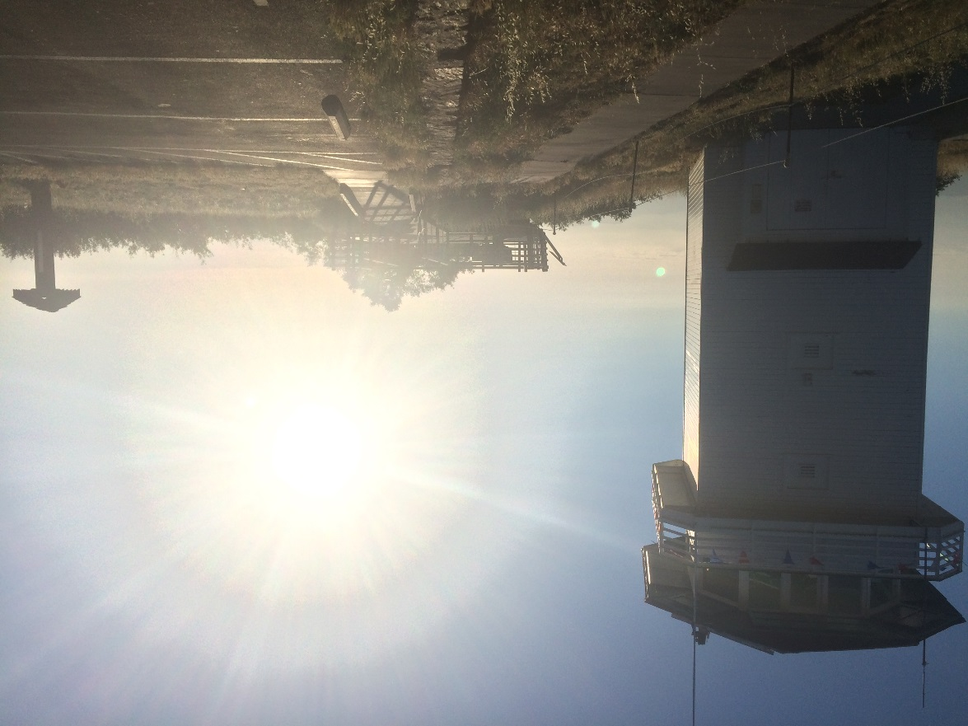

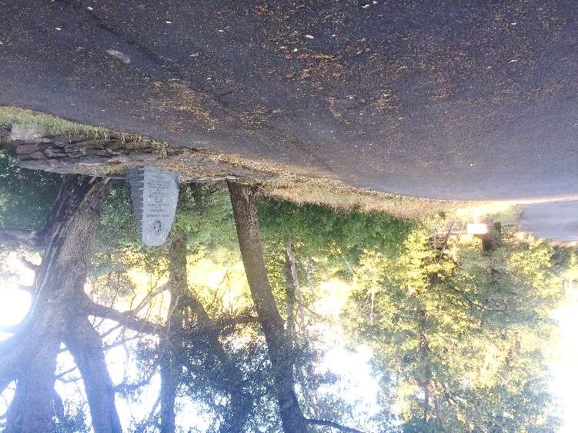
• July 3rd • 6:30pm
• ~ 2 mi round-trip
• easy-mod. hike
• Meet at Boucher Trail
• Parking - @ Silvercrest
Parking available near the start of Boucher Trail at the CCC Memorial
Or along the road near
CCC Memorial

