
Birding Walk
JOIN

US
!
JOIN

US
!
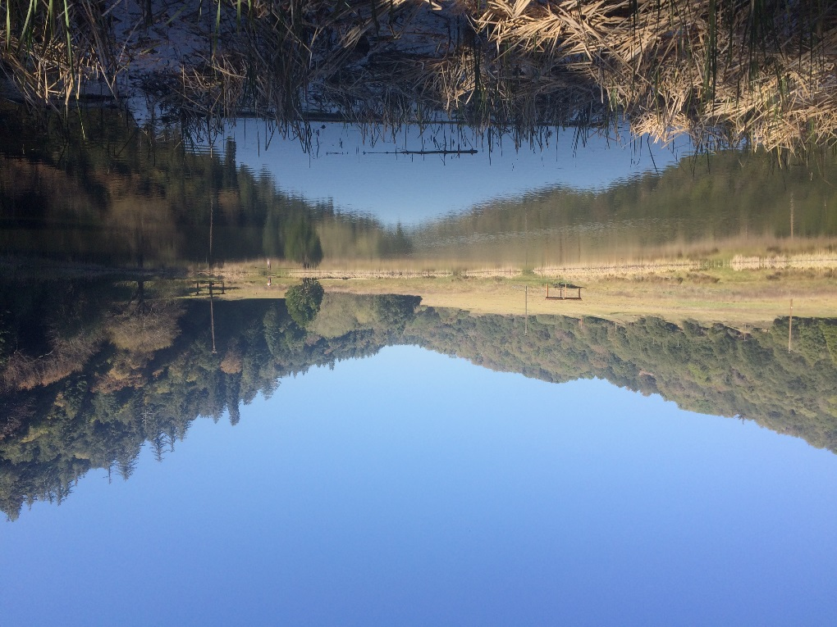

• Meet @ Doane Pond •
• B.Y.O.B (bring your own binoculars) •
• 3:00pm • All ages welcome! •
• Lasts until 4:00pm • Hiking around Doane Pond and Doane Valley Nature Trail •
We will be searching for species like Red-tailed Hawks, Orioles, and Mallards!

